An Example Based on Radix Coding

Input :
rat
mop
 | 0 | 1 | 2
0 | r | a | t
1 | m | o | p
2 | c | a | t

cat

A[MAX][KEYSIZE]
A[3][3] = { {r,a,t} , {m,o,p} , {c,a,t} }

//to determine the position for a new list
//checking on the last letter in the list (KEYSIZE –1)
//j = 2

void RadixSort(char a[MAX][KEYSIZE])
{
int i,j;
Queue queues[28];
for (j=KEYSIZE-1;j>=0;j--) //checking on the last letter in the list
{
for (i=0;i<MAX;i++)
queues[QueuePosition(a[i][j])].Addend(a[i]);
// …
}

the first call parameter : queues[QueuePosition(a[0][2])].Addend(a[0])
queues[QueuePosition(t)].Addend(a[0])

int QueuePosition(char c)
{
//this function return 0 if there is no character (NULL), or return the character to be
// position in the new list or return 27 if ESC key is pressed

if (c==' ')
return 0;
else if (isalpha(c)) //return a non-zero value if c is within the ranges
//A-Z or a-z.
return tolower(c)-'a'+1;
else
return 27;
}

In ASCII code, ‘t’ is equivalent to 116 and ‘a’ is equivalent to 97. Therefore, the return result is 116-97+1 = 20

queues[20].Addend(a[0])

This command will add ‘rat’ to queue at position 20 by using the command strcpy(strDestination, strSource)

class Queue
{
char Q[MAX][KEYSIZE];
int head,tail;
public:
Queue()
{
head=0;
tail=-1;
}

void Initialize()
{
head=0;
tail=-1;
}

void Addend(char x[KEYSIZE])
{
if (!Full())
{
tail++;
strcpy(Q[tail],x);
}
else cout<<"Full Queue"<<endl;
}
};

This process will repeat for the rest of the element. At the end of the for loop (j= 2), this is the result :-

queue
0
1
2
---
mop
16
17
18
19
20
rat
cat
---

At the end of the for loop (j= 1) [comparing the 2nd letter], this is the result :-

queue
0
rat
cat
1
2
---
mop
15
16
17
18
19
---

At the end of the for loop (j= 0) [comparing the 1st letter], this is the result :-

queue
0
1
2
3
cat
---
12
mop
13
14
15
16
17
rat
18
---

Exercise :

Sort the below list using Radix Sort. Show the steps of derivation.

10 1234 9 7234 67 9181

Answer:
9 10 67 1234 7234 9181

ASCII Character Coding

Code 0 to 127
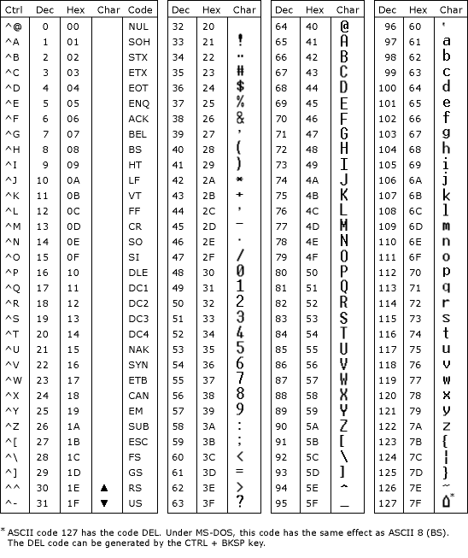

Code 128 – 255
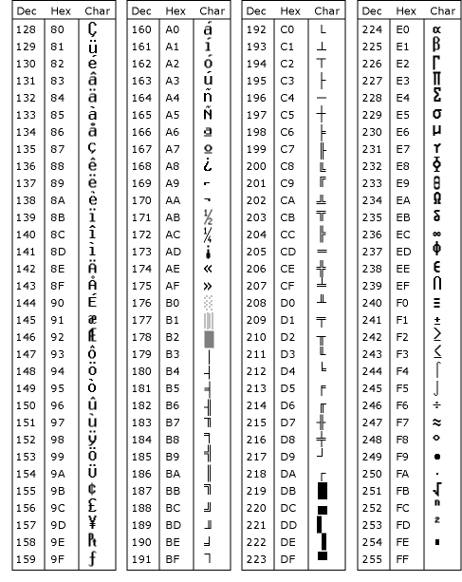

Radix sort is a small method that many people intuitively use when alphabetizing a large list of names. (Here Radix is 26, 26 letters of alphabet).
Specifically, the list of names is first sorted according to the first letter of each names, that is, the names are arranged in 26 classes.
Intuitively, one might want to sort numbers on their most significant digit. But Radix sort do counter-intuitively by sorting on the least significant digits first.
On the first pass entire numbers sort on the least significant digit and combine in a array. Then on the second pass, the entire numbers are sorted again on the
second least-significant digits and combine in a array and so on.

Following example shows how Radix sort operates on seven 3-digits number.

INPUT 1st pass 2nd pass 3rd pass
329 720 720 329
457 355 329 355
657 436 436 436
839 457 839 457
436 657 355 657
720 329 457 720
355 839 657 839

In the above example, the first column is the input. The remaining shows the list after successive sorts on increasingly significant digits position.
The code for Radix sort assumes that each element in the n-element array A has d digits, where digit 1 is the lowest-order digit and d is the highest-order digit.

RADIX_SORT (A, d)

for i ? 1 to d do
use a stable sort to sort A on digit i
// counting sort will do the job

Analysis

The running time depends on the stable used as an intermediate sorting algorithm. When each digits is in the range 1 to k, and k is not too large, COUNTING_SORT is the obvious choice.
In case of counting sort, each pass over n d-digit numbers takes O(n + k) time. There are d passes, so the total time for Radix sort is (n+k) time. There are d passes, so the total time
for Radix sort is (dn+kd). When d is constant and k = (n), the Radix sort runs in linear time.

http://www.personal.kent.edu/~rmuhamma/Algorithms/MyAlgorithms/Sorting/radixSort.htm
http://www.ics.uci.edu/~eppstein/161/960123.html

Radix Sort

We wish to sort an array with n positive integers. Assume all integers have at most 10 digits.

Solution:

- Create 10 queues labeled Q_0, …, Q_9.
- Scan the array and “place” a scanned integer in Q_k where k is the last digit of the current number scanned.
- Copy back Q_0, Q_1,…,Q_9 to the array.

Example:

928 205 714 693 332 13 227 128
944 773 374 569 207 576 725 548
761 449 726 748 585 295 194 718

761
332
693 13 773
714 944 374 194
205 725 585 295
576 726
227 207
928 128 548 748 718
569 449

These are the 10 queues.
The new array is:

761 332 693 13 773 714 944 374
194 205 725 585 295 576 726 227
207 928 128 548 748 718 569 449

Repeat step b and c for the second digit from the right, the third and so on. The final array will be sorted.

205 207
13 714 718
725 726 227 928 128
332
944 548 748 449
761 569
773 374 576
585
693 194 295

Note: Q_5 is empty. The new array is:
205 207 13 714 718 725 726 227
928 128 332 944 548 748 449 761
569 773 374 576 585 693 194 295

Queue by next digit:

13
128 194
205 207 227 295
332 374
449
548 569 576 585
693
714 718 725 726 748 761 773
928 944

And the final array is sorted:

13 128 194 205 207 227 295 332 374 449 548 569 576 585 693 714
718 725 726 748 761 773 928 944

Analysis:

If the initial array contains 10 digit integers after 10 passes the array will be sorted. During each pass an integer is placed in a queue and at the end of the pass it is dequeued and place back in the array. Assuming that each placement in a queue and dequeuing takes a constant time c, the running time of this algorithm is: 10cn = O(n).

This of course ignores the cost of managing the queues. A clever implementation of the queues can render this code to be very efficient:

- Create an array count[10], count[n] = number of integers in Q_n.
- Create an array index[10], index[n] will “point” the insertion location in the final array of current integer at the top of Q_n.

The revised pseudo-code will be:

- Let A be the current array and B another array (we shall alternate copying the integers from A to B and back).
- Pass k: scan the array, count[n]++ if the k-th digit from the right of the current scanned integer = n.
- index[0] = 0;
for (i = 1; i < 10; i++)
index[i] = index[i – 1] + count[i – 1];
- Copy the initial array A to the array B as follows: if the k-th digit from the right of A[m] = n then
B[index[n]] = A[m];
Index[n]++;

Drill: apply (paper/pencil) this algorithm to the following array:

2070 6582 6186 9005 4302 4713 888 8669 7808 4350 6629 8443 5128 1918 5957 8825 4184 9203 1321 8596 8109 3745 2138 4722 3565 1030 2965 7089 3067 5408 1317 7698

- How many passes will be required to sort this array?
- Show the arrays count[] and index[] after each pass.

An even more efficient implementation of these cleverly simulated queues can be obtained by using low level operations on integers as is illustrated in the following code for Radix-sorting 32-bits positive integers.

//Radix sort method: a clever simulation of queues
public static void Radix(int source[])
{
int temp[] = new int[source.length];

radix_pass(0, source, temp); // least-significant-byte
radix_pass(1, temp, source);
radix_pass(2, source, temp);
radix_pass(3, temp, source); // most-significant-byte
}

private static void radix_pass(int int_byte, int source[], int dest[])
{
int count[] = new int[256]; // holds a count of the number of integers in each queue
int index[] = new int[256];
// index[i] will store the location in the array currently on top of queue_i
int i;
int int_bit = int_byte * 8; // numberof bits to shift

for (i = 0; i < source.length; i++)
count[ (source[i] >> int_bit) & 0xff ]++; //extract byte shifted by int_bit
index[0]=0;
for (i = 1; i < 256; i++)
index[i] = index[i-1] + count[i-1]; //initialize index[]
/* Place integers in their proper location as pointed to by index[] and increment index to point to the next location. */
for (i = 0; i < source.length; i++)
dest[ index[ (source[i] >> int_bit) & 0xff ]++ ] = source[i];
}

